JOIN THE MOVEMENT!!
The Arc of Alabama works to ensure that all people with intellectual and developmental disabilities have optimal opportunities across their lifespan.

Through legislative and systems advocacy, educational, information and referral, and other programs, The Arc of Alabama promotes choice and advocates for the rights of people with I/DD to enjoy full participation in their communities throughout their lifetime.

The Arc of Alabama manages by the values: integrity, respect, courage, and justice.

Call or visit us today to learn how you can be part of our ADVOCACY!!

The Arc of Alabama is a 501(c)(3) not for profit organization. Donations to
The Arc of Alabama are tax-deductible.

Connect With Us

www.facebook.com/thearcofalabama www.twitter.com/thearcofalabama

Self-Directed Services
Decide when, where, how, and from whom your services are delivered.

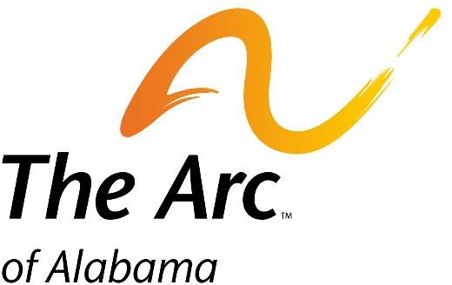
The Arc of Alabama
557 S. Lawrence Street Montgomery, AL 36104
334.262.7688

www.thearcal.org

For people with intellectual and developmental disabilities

What is Self-direction?
“Self-Determination” is a way to receive waiver services in your home:
- Where you are in Control
- Βased on your needs
- You choose your own workers
- You decide when and how
- Self-Managing your workers
Getting Services through self-direction is not the same as getting them through an agency. In self-direction, you are the employer of your workers. Your workers work for you, not for an agency
Self-Direction is based on the idea that people who receive services know best what their needs are and how those needs should be met. This mode; is very flexible to help give you control over your life

What Are My Responsibilities?
When you receive services in self-direction, you are in control. This means you will have responsibilities, like:
- Choosing who works for you
- Scheduling your workers
- Training your workers
- Giving your workers feedback on services they provide
You will always have help available when you self-direct. Your case manager can help answer your questions.

For more info about self-directed services:
https://mh.alabama.gov/self-directed-service/

Is Self-Direction Right For Me?
Choosing to self-direct is a big decision. Because you are in control, you may have to make more decisions than you would if receiving services through an agency.
Below are some questions to help you think through what self-directing might be like for you.
- Do you know anybody you might hire?
- Can you show your worker how to provide the care you need?
- Can you tell what you like or dislike about their work
- Can you manage a worker’s schedule?
If you answered no to any questions above, you can still have another person act as your representative. This could be a family member or someone you know

Why Choose Self-Direction

Over 1 million Americans currently self-direct their services. People choose to self-direct for many different reasons
- “Wanting more control over own services
- Wanting to purchase items with own savings
- Not felling satisfied with current services
- Wanting to hire someone you know
- You live in an area where services are not always available to receive care from an agency

Support Coordination

For More information on support Coordination:

https://mh.alabama.gov/division-of-developmental-disabilities/support-coordination/

What To Do
It is important to be open with your case manager when you talk with them. It is your job to make sure you are safe and help protect you. Always tell them if you think something might be wrong or someone is making you uncomfortable. Your case manager can also give you important phone numbers in case you need help, like a confidential hotline.

A Self-Directed Service plan should reflect the breakdown of services an individual can receive. This plan is developed by the individual, case manager, and their circle of support. Some Waiver Services that can be received on Self Directed Service Plan are:

- Assistive Technology Services
- Behavioral Support Services
- Day Habilitation
- Employee Discovery and Customization
- Environmental assistance
- Family and Peer Mentoring Supports
- Housing Support Services
- Live-In Caregiver Supports
- Transportation
- Transition Services

Community Service Regions:
Region I 256-898-2789
Region II 205-554-4302
Region III 251-283-6200
Region IV 334-676-5565
Region V 205-916-7800

If you are not on the waiver and wish to apply contact ADMH Call Center 1-800-361-4491

www.thearcofal.org

